Great Lakes Bay Region Mental Health Partnership
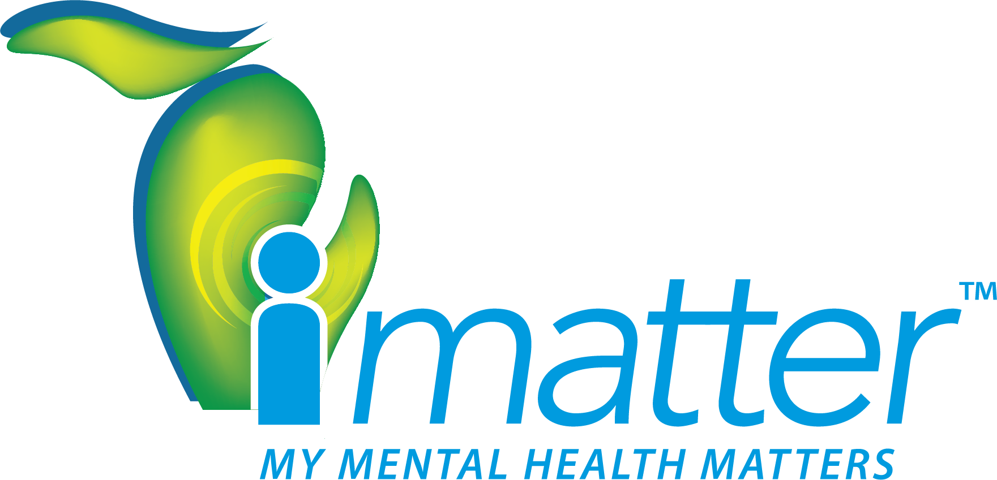
iMATTER
TOOLKIT
TOOLKIT FOR TEACHERS, SCHOOL DISTRICTS AND COUNSELORS
Welcome
This toolkit will provide you with resources to
communicate the importance of mental health, share
help lines and showcase that each person matters!
Dear School Superintendent:
I want to thank you for your support in implementing the I Matter mental health awareness toolkit for the students in your district. We know that 50% of all lifetime cases of mental illness begin by age 14, and 75% by age 24. It is important to reach young people – and their parents – so they can better understand mental illness, its symptoms and how to get help.
There are so many misconceptions tied to mental illness and we need to address those now. It is my hope that this toolkit helps students realize that mental illness – like other illness – is treatable. Help is available. They are not alone.
I would appreciate feedback from you as you implement the various resources found in this toolkit.
Please, don’t hesitate to reach out if you have any questions.
Thanks, again, for your support of this important work.
Dr. Matt Samocki
Steering Team Member | Great Lakes Bay Region Mental Health Partnership
Great Lakes Bay Regional Alliance
E: msamocki@greatlakesbay.org
W: www.greatlakesbay.com/mentalhealth

Table of Contents
Overview: Great Lakes Bay Region Mental Health Partnership 4
How to Use This Toolkit 5
Email to Parents 6
Email to Counselors 7
Email to Staff 8
Social Media Posts 9
Morning Announcements 10
Bathroom Stall Messages 11
Flyer 13
Contact Card 15
iMatter Video 18
Overview: GLBR Mental Health Partnership
History
With unanimous support from the 40+ Board of Directors for the Great Lakes Bay Regional Alliance, the Great Lakes Bay Region Mental Health Partnership began in 2018 when it was agreed upon that there is a mental health crisis in our region. A key initial driver and funder of this initiative were the Family and Friends of Chad William Dunn who, as a result of mental illness, died by suicide on July 29, 2013. The initiatives' current key supporters include the National Network of Depression Centers, Central Michigan University College of Medicine, The Dow Company Foundation, University of Michigan Depression Center, Michigan Health Improvement Alliance and THRIVE. The Great Lakes Bay Region Mental Health Partnership is a Joint Associate Member of the National Network of Depression Centers in collaboration with the Central Michigan University College of Medicine.
Mission
Collaborate with stakeholders to proactively tackle the mental health crisis as a community to help people obtain the best possible care.
Vision
Ensure that everyone in the Great Lakes Bay Region knows where to turn for help when struggling with
a mental health issue, seeks help without fear of stigma and receives prompt access to excellent care.
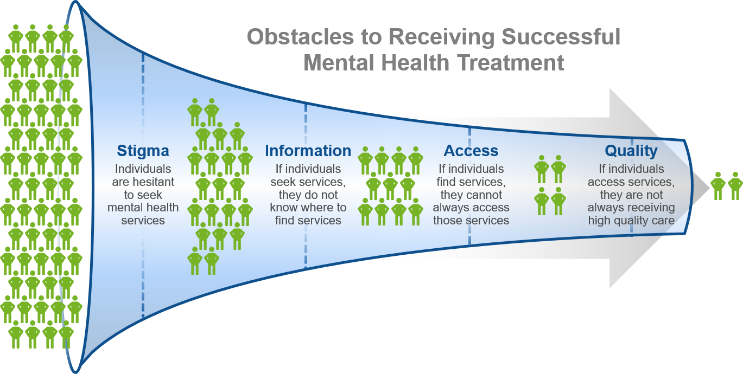
Problem Pipeline

“The Great Lakes Bay Region Mental Health Partnership is working on addressing the mental health crisis in our area. We envision an educated youth, equipped with the knowledge and resources for social and emotional health along with the resiliency to face life's extraordinary demands. I urge you to join me in the critical role of connecting children and adolescents with the appropriate mental health resources in the region. It is only through collaboration that we will impact the stigma and barriers associated with mental health care.”
– Stephen Bigelow
Superintendent, Bay City Public Schools, Youth Information Work Group Member
How to Use This Toolkit
This toolkit contains a variety of resources to help each school building implement a successful campaign aimed at raising awareness of mental health and acceptance of mental illness. Here is a list of the contents and how they might be used:
- E-mail to Parents: This is a letter that you – or your delegate – can send to parents of students. The letter can be easily customized to meet your needs.
- E-mail to Counselors: This is a letter that you – or your delegate – can send to school counselors. The letter can be easily customized to meet your needs.
- E-mail to Staff: This is a letter that you – or your delegate – can send to building staff. The letter can be easily customized to meet your needs.
- Social Media Posts: These are some sample social media postings that could go out from you or any delegates. Feel free to create your own, as well. We want to highlight the good work being done by the schools to tackle the stigma surrounding mental illness.
- Morning Announcements: These are some sample messages for morning announcements. The idea is to sprinkle these into the daily routine as often as possible, to make mental health part of our everyday conversations.
- Bathroom Stall Messages: You will be receiving ½ page bathroom stall messages for distribution to your schools. Please ask the principals to have them posted in bathrooms. You can print additional copies from this toolkit, if needed.
- Flyers: You will be receiving flyers for distribution to your schools. Please ask the principals to have them posted throughout their school buildings. You can print additional flyers from this toolkit, if needed.
- Contact Cards: You will be receiving contact cards to give to students, as needed. You can print additional contact cards (on card stock) from this toolkit.
- iMatter video: You could show this 30-second video, which tackles mental illness and stigma in a very positive way. This powerful message should be well received by students.

We hope this toolkit will raise awareness about mental health – and the high-quality, confidential resources that are available, 24/7. If you have any questions, send an email to: msamocki@greatlakesbay.org

Email to Parents
As the school year begins, we wanted to make you aware of resources and partnerships in our area that are taking on the mental health crisis. Nationwide the statistics are sobering:
- 50% of all lifetime cases of mental illness begin by age 14, and 75% by age 24¹
- 20% of youth ages 13-18 live with a mental health condition¹
- The average delay between onset of symptoms and intervention is 8-10 years¹
The Great Lakes Bay Region Mental Health Partnership was established in 2018 with the goal of working with community stakeholders and resources to address the mental health crisis in the Great Lakes Bay Region. It is focused on assisting students by increasing awareness and sharing information about how they can get help – 24/7.
Our school administrators, teachers and counselors will receive an overview about the Mental Health Partnership and resources available to help students. They will be sharing two help lines:
- Call: 1-800-662-HELP (4357)
Substance Abuse & Mental Health Services Administration (SAMHSA)
- Text: BELONG to 741741
Crisis Text Line® counseling
Both are nationwide resources that the Great Lakes Bay Region Mental Health Partnership has researched to ensure that connecting to assistance is effective and anonymous.
We ask you to join us in raising awareness by talking with your kids about mental health and supporting these efforts. We want all our students to know they MATTER!
Sincerely,
INSERT NAME OF SUPERINTENDENT OR DELEGATE

NAMI. (2015). Mental Health by the Numbers. Retrieved from https://www.nami.org/Learn-More/Mental-Health-By-the-Numbers

Email to Counselors
Dear Counselors:
As the school year begins, we wanted to make you aware of resources and partnerships in our area that are taking on the mental health crisis. Nationwide the statistics are sobering:
- 50% of all lifetime cases of mental illness begin by age 14, and 75% by age 24¹
- 20% of youth ages 13-18 live with a mental health condition¹
- The average delay between onset of symptoms and intervention is 8-10 years¹
The Great Lakes Bay Region Mental Health Partnership was established in 2018 with the goal of working with community stakeholders and resources to address the mental health crisis in the Great Lakes Bay Region. It is focused on assisting students by increasing awareness and sharing information about how they can get help – 24/7. We will be promoting two help lines:
- Call: 1-800-662-HELP (4357)
Substance Abuse & Mental Health Services Administration (SAMHSA)
- Text: BELONG to 741741
Crisis Text Line® counseling
Both are nationwide resources that the Great Lakes Bay Region Mental Health Partnership has researched to ensure that connecting to assistance is effective and anonymous.
At the beginning of the school year, you will be receiving contact cards and flyers with this information. The contact cards are small, so they can easily fit in a student’s pocket.
We need your support to make this effort successful. Please join us so all our students know they MATTER!
Sincerely,
INSERT NAME OF SUPERINTENDENT OR DELEGATE

NAMI. (2015). Mental Health by the Numbers. Retrieved from https://www.nami.org/Learn-More/Mental-Health-By-the-Numbers

Email to Staff
Dear Staff:
As the new school year begins, we want to make sure that the front-line contacts with our students are prepared to answer questions about mental health that may arise during the year.
The Great Lakes Bay Region Mental Health Partnership was established in 2018 with the goal of working with community stakeholders and resources to address the mental health crisis in the Great Lakes Bay Region. Nationwide the statistics are sobering:
- 50% of all lifetime cases of mental illness begin by age 14, and 75% by age 24¹
- 20% of youth ages 13-18 live with a mental health condition¹
- The average delay between onset of symptoms and intervention is 8-10 years¹
Many kids struggle in silence with mental health issues. Further, stigma keeps many students and families from accessing care. The Partnership is focused on assisting students by raising awareness and directing them to the following help lines:
- Call: 1-800-662-HELP (4357)
Substance Abuse & Mental Health Services Administration (SAMHSA)
- Text: BELONG to 741741
Crisis Text Line® counseling
Both are nationwide resources that the Great Lakes Bay Region Mental Health Partnership has researched to ensure that connecting to assistance is effective and anonymous. At the beginning of the school year, you will be receiving flyers with this information.
In addition, we have created a 30-second video that tackles mental illness and stigma in a very positive way. This powerful message should be well received by students.
We need your support to make this effort successful. Please join us so all our students know they MATTER!
Sincerely,
INSERT NAME OF SUPERINTENDENT OR DELEGATE

NAMI. (2015). Mental Health by the Numbers. Retrieved from https://www.nami.org/Learn-More/Mental-Health-By-the-Numbers

Social Media Posts
The following image can be used with any social media posts.
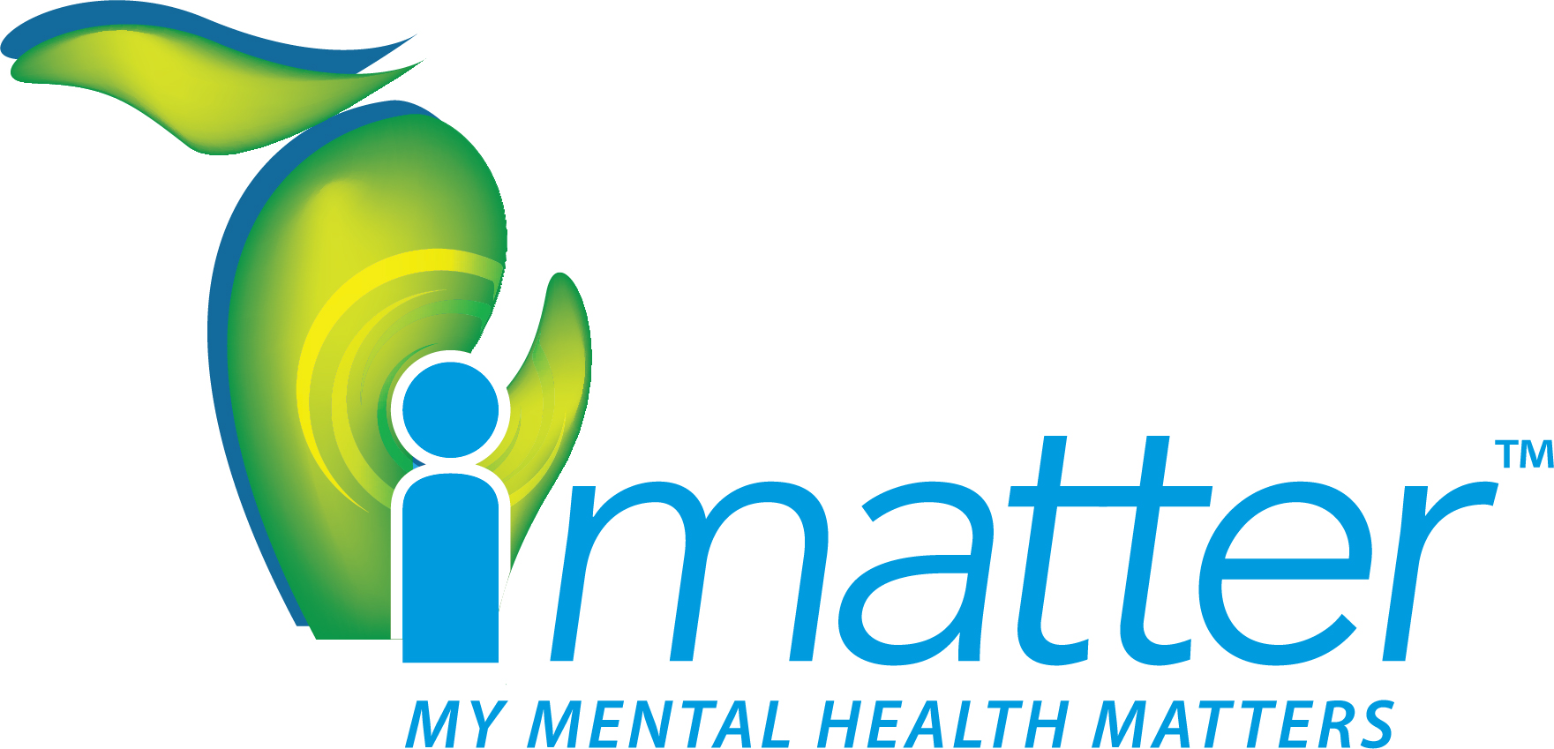

The image can be accessed at either of the links below:
- JPG file with white background

- PNG file with no background

Facebook
Example #1:
We want all students to know they Matter. We are here for each and every one of you. If you need to talk to someone: Call 1-800-662-HELP (4357) or text BELONG to 741741. Remember, Remember I matter and my mental health matters!
Example #2:
Mental Health is just as important as physical health. Hear from Olympic athletes Michael Phelps and Allison Schmitt about the importance of helping those around you receive help. Remember I matter and my mental health matters. https://www.youtube.com/watch?v=hIVsJiJP0Lw.
Example #3:
We want you to know You Matter. Your life, your feelings, your dreams – all matter. If you are having a tough time: Call 1-800-662-HELP (4357) or text BELONG to 741741. Remember, Remember I matter and my mental health matters!
Example #4:
If someone you care about is experiencing a tough time, reach out to let them know they matter. Or, if you are personally experiencing a tough time, it is okay to ask for help yourself. Call 1-800-662-HELP (4357) or text BELONG to 741741. Remember, Remember I matter and my mental health matters!

Twitter
Example #1:
We believe that everyone matters. If you are having a tough time: Call 1-800-662-HELP (4357) or text BELONG to 741741. Remember, Remember I matter and my mental health matters! #iMatter
Example #2:
My mental health matters! If you are having a tough time: Call 1-800-662-HELP (4357) or text BELONG to 741741. Take that first step to talk to someone. #iMatter
Example #3:
Having a tough time? Call 1-800-662-HELP (4357) or text BELONG to 741741. Take that first step to talk to someone. #iMatter

Morning Announcements
- Example #1:
Here is your iMatter Moment for this morning…
From time to time, we all get thoughts like “maybe I won’t do well on this test,” or “maybe she doesn’t like me.” But when those thoughts become overwhelming or prevent you from doing things you want to do, then it’s time to talk to a trusted adult.
- Call:1-800-662-HELP (4357), or
- Text: BELONG to 741741
Remember, I matter and my mental health matters!
- Example #2:
Here is your I Matter Moment for this morning…
What do you do when you feel sad, anxious or angry? It can be really helpful to talk with someone you trust – a teacher… a coach… a parent… or another adult family member or friend. If you need to talk:
- Call:1-800-662-HELP (4357), or
- Text: BELONG to 741741.
Our school wants everyone to know that You Matter!
- Example #3:
Here is your iMatter Moment for this morning…
If someone you care about is experiencing a tough time, reach out to them to let them know they matter. And, if you are experiencing a tough time, it is okay to ask for help yourself.
- Call:1-800-662-HELP (4357), or
- Text: BELONG to 741741.
Remember, I matter and my mental health matters!
- Example #4:
Here is your iMatter Moment for this morning…
When you’re having a tough time, it’s important to take that first step and talk to someone. Help is available, 24/7.
- Call:1-800-662-HELP (4357), or
- Text: BELONG to 741741.
Remember, I matter and my mental health matters!

Bathroom Stall Messages
The next page contains a printable version of the bathroom stall messages (snippets shown below), in case you need additional copies.
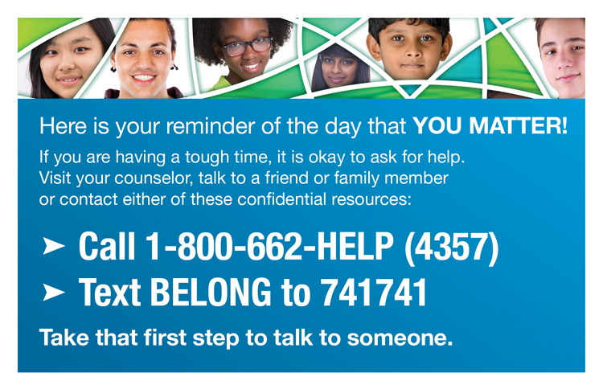
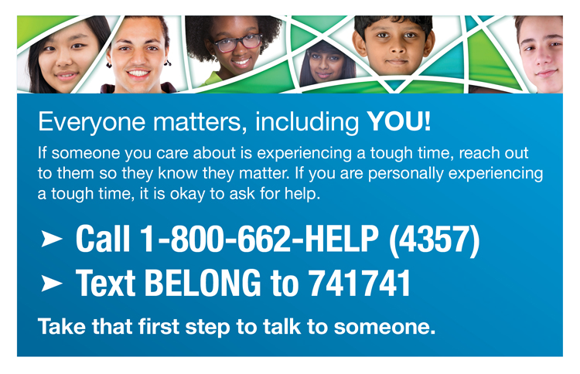
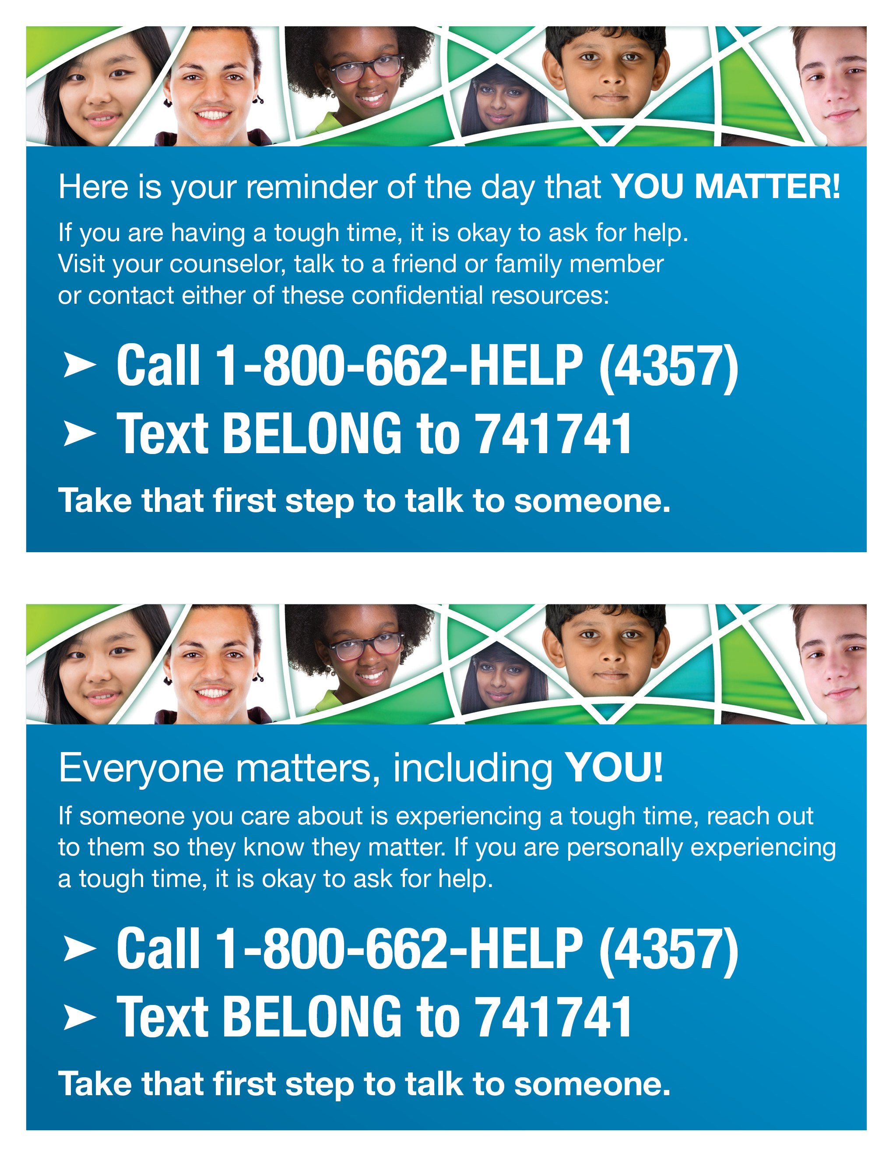
Flyer
The next page contains a printable version of the flyer (snippet shown below), in case you need additional copies.
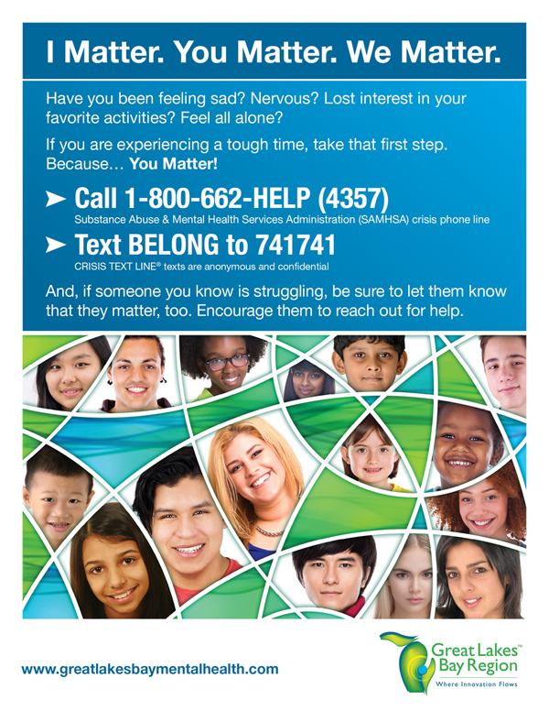
www.greatlakesbay.com/mentalhealth
www.greatlakesbay.com/mentalhealth
www.greatlakesbay.com/mentalhealth
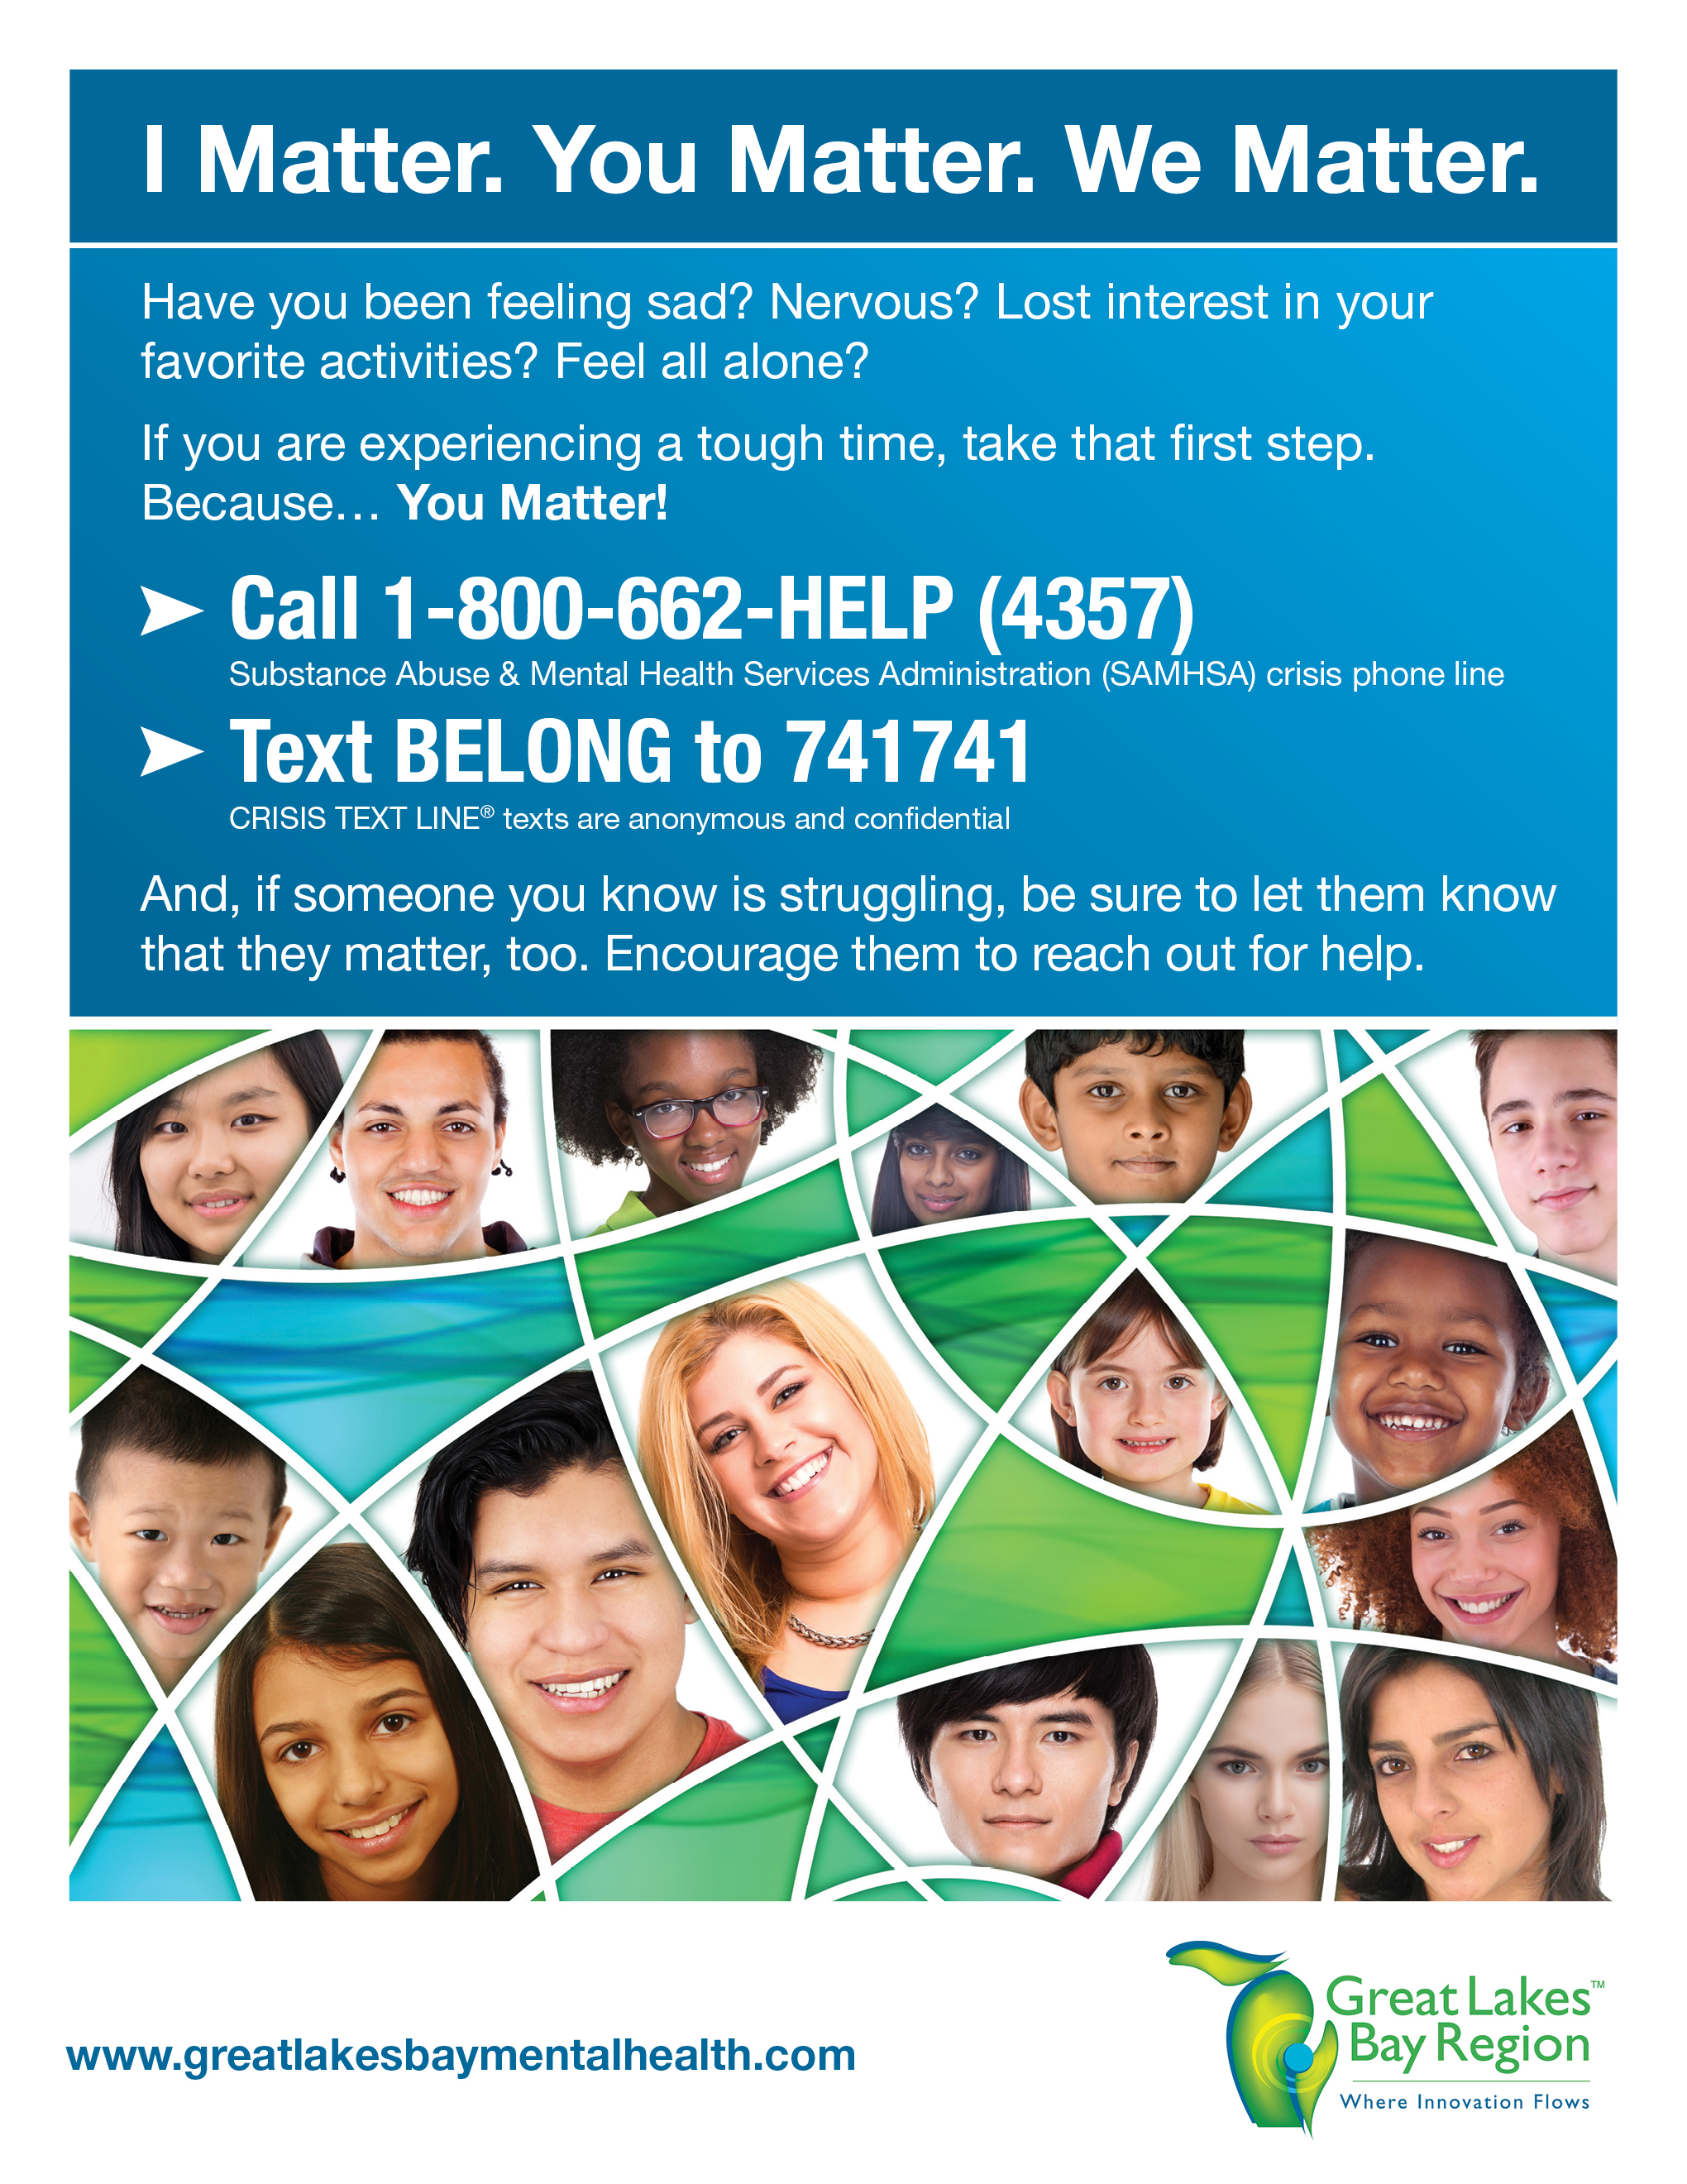
www.greatlakesbay.com/mentalhealth
Contact Card
The next two pages contain printable versions of the contact card (snippets shown below), in case you need additional cards. Please print the pages back-to-back. They can be printed on heavy card stock and trimmed.
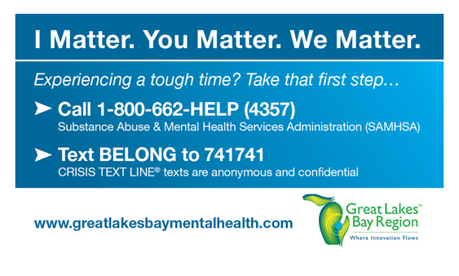
www.greatlakesbay.com/mentalhealth
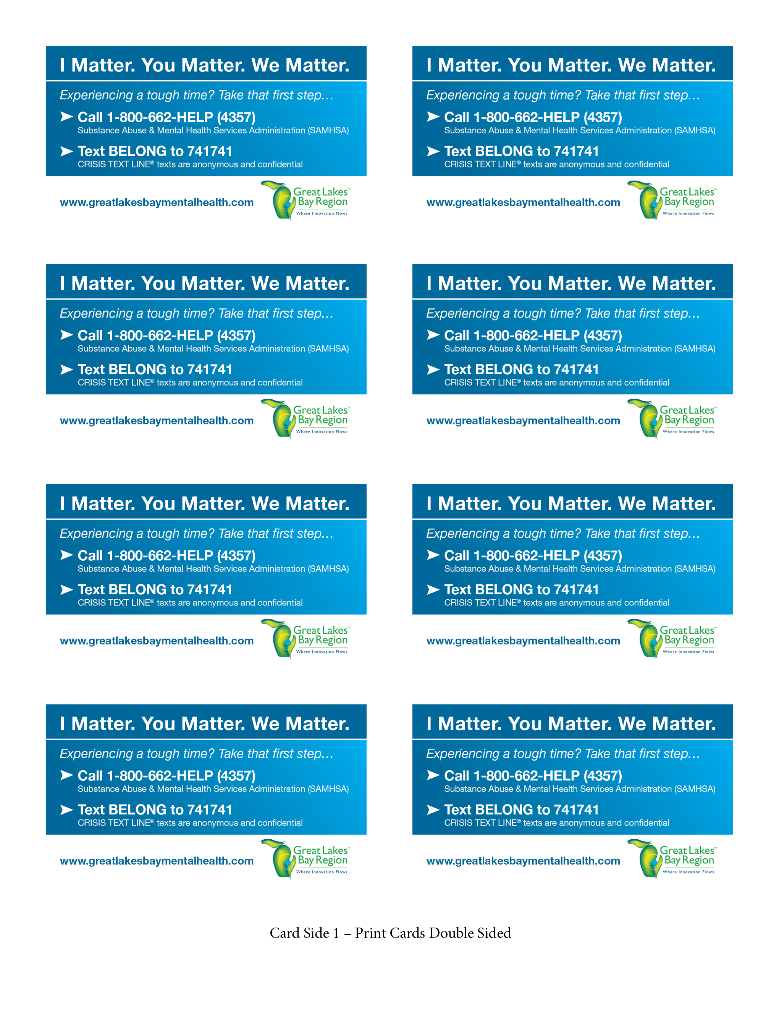
www.greatlakesbay.com/mentalhealth
www.greatlakesbay.com/mentalhealth
www.greatlakesbay.com/mentalhealth
www.greatlakesbay.com/mentalhealth
www.greatlakesbay.com/mentalhealth
www.greatlakesbay.com/mentalhealth
www.greatlakesbay.com/mentalhealth
www.greatlakesbay.com/mentalhealth
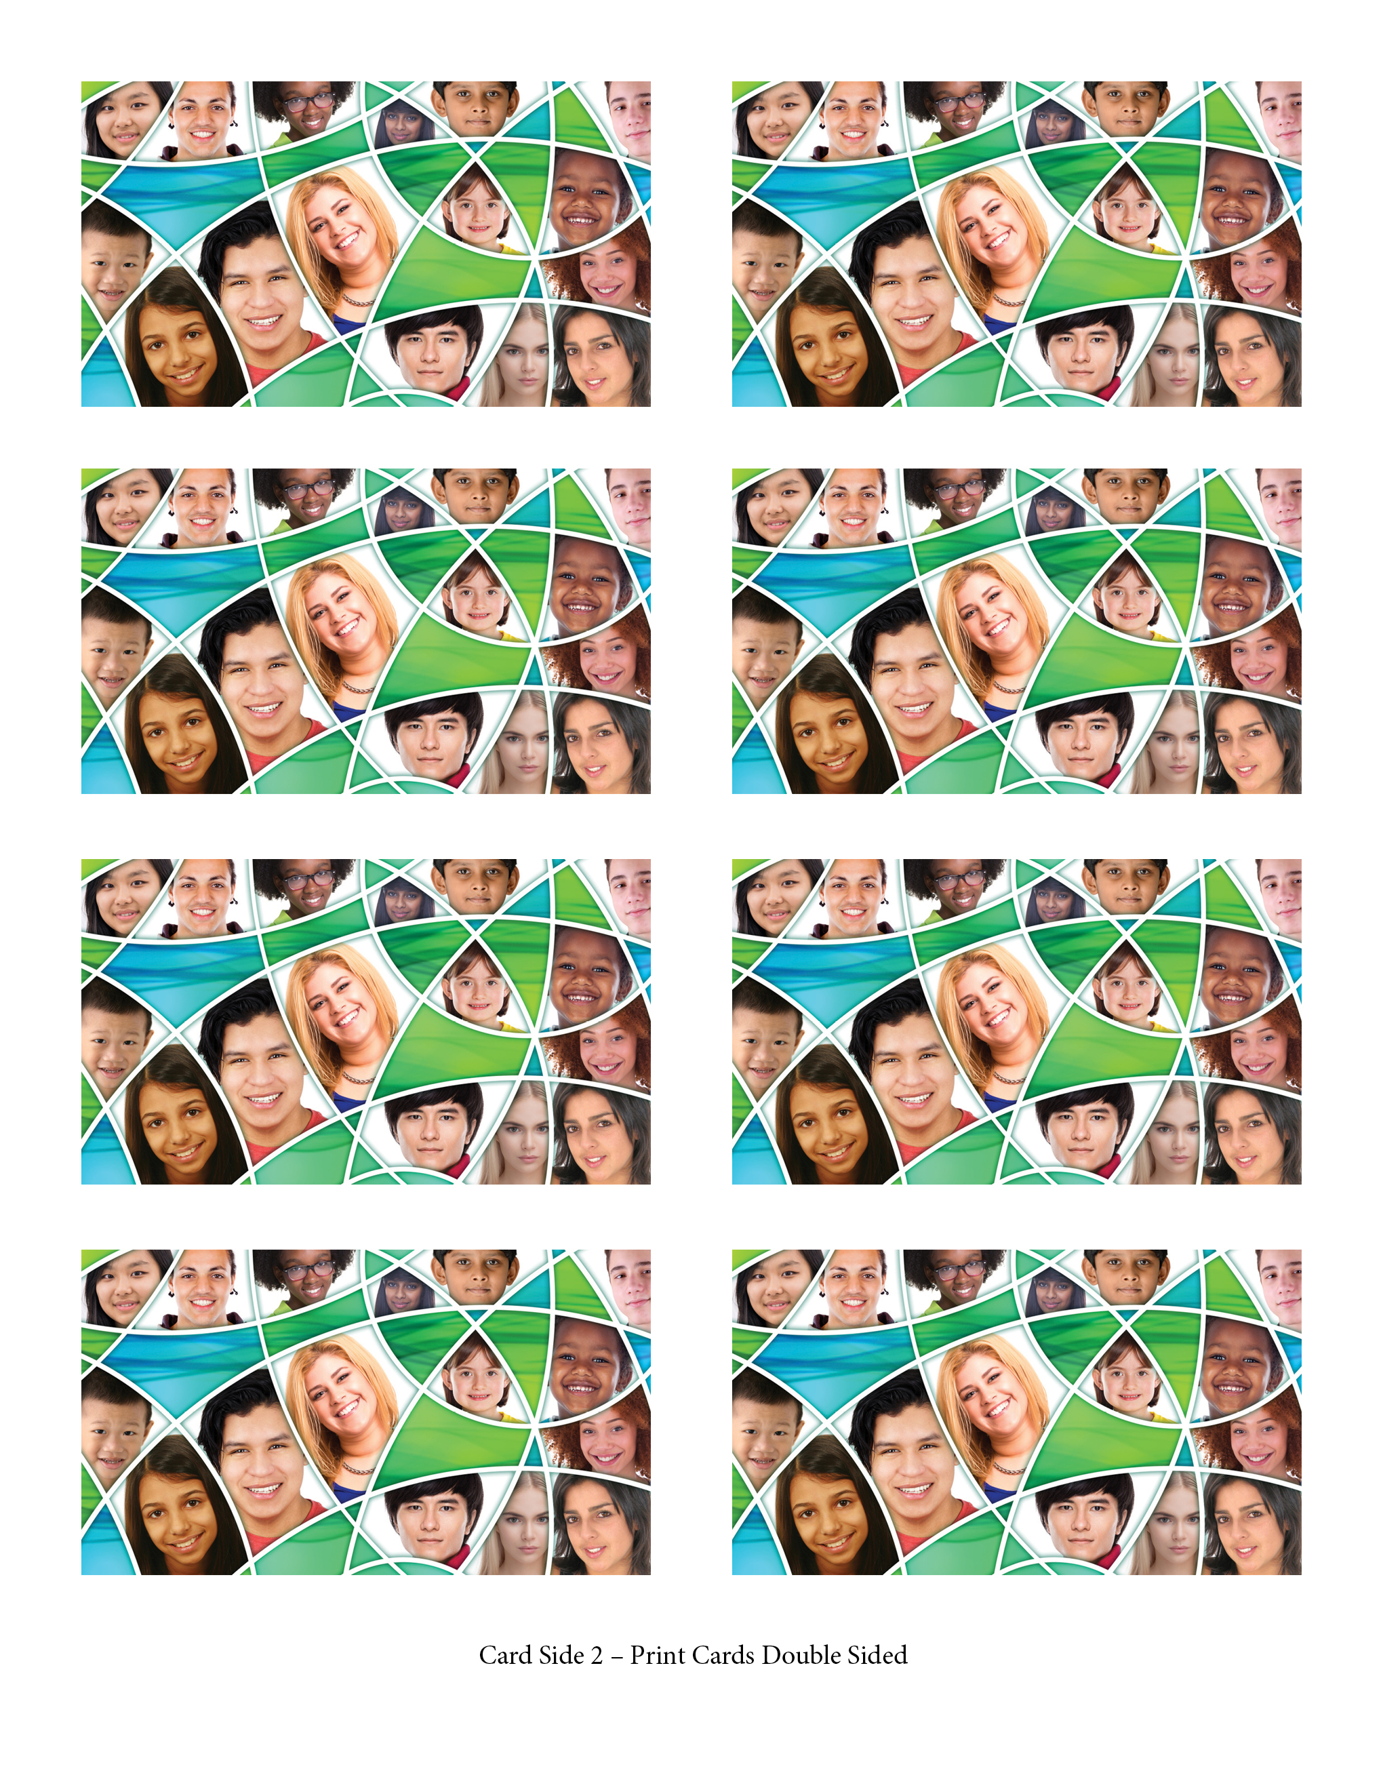

iMatter Video
Click on the image below to view the video. You can also download the video, if you prefer.
